- Find missing bills in zatca

Recon format:
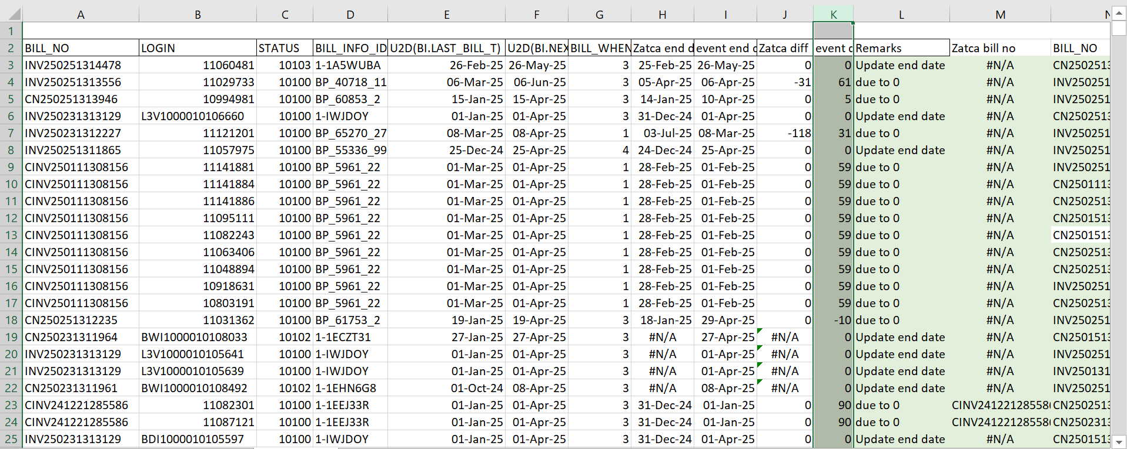

select distinct bi.bill_info_id,bi.billmode,bn.bill_no,bn.due,u2d(bn.end_t)
from pin01.service_T s ,pin01.billinfo_T bi,pin01.bal_grp_T b,pin01.bill_T bn
where s.bal_grp_obj_id0=b.poid_id0 and b.billinfo_obj_id0=bi.poid_id0 and bn.billinfo_obj_id0=bi.poid_id0
and bn.due <>0
and bn.bill_no not like '%OPP_Bal-%' and bn.bill_no not like 'B1%'
and u2d(bn.end_t) >='01-Jan-25' and u2d(bn.end_t) <='28-FEB-25'
and bn.bill_no not in (select distinct INVOICE_NUMBER from pinbo.all_zatca_invoices --where INVOICE_ISSUE_DATE>='01-Jan-25'
);
- Take service details

select distinct INVOICE_NUMBER from pinbo.all_zatca_invoices where INVOICE_NUMBER in ('CN250231314118','CN250111305239');

--- Take SID only from below SID
select b.bill_no,s.login
from pin01.item_t i ,pin01.event_t e ,pin01.event_bal_impacts_T eb,pin01.bill_T b, service_t s
where i.poid_id0=e.item_obj_id0 and e.poid_id0=eb.obj_id0
and i.bill_obj_id0=b.poid_id0
and e.service_obj_id0= s.poid_id0
and b.bill_no in ('INV241251283219','CN250251311509')
and eb.amount>0
order by e.created_t desc;

--- Billinfo details from below query

select distinct s.login,s.status,bi.bill_info_id,bi.billmode,b.bill_no,b.due,u2d(b.end_t),u2d(bi.last_bill_T),u2d(bi.next_bill_t),bi.bill_when
from pin01.service_T s ,pin01.billinfo_T bi,pin01.bal_grp_T bg,pin01.bill_T b
where s.bal_grp_obj_id0=bg.poid_id0 and bg.billinfo_obj_id0=bi.poid_id0 and b.billinfo_obj_id0=bi.poid_id0
and b.due <>0
and b.bill_no in ('INV241251283219','CN250251311509');

- Zatca max end date for service

select distinct service_id,max(SUPPLY_END_DATE) from pinbo.all_zatca_invoices where INVOICE_TYPE='Tax Invoice' and
service_id in (select distinct s.login
from pin01.service_T s ,pin01.billinfo_T bi,pin01.bal_grp_T bg,pin01.bill_T b
where s.bal_grp_obj_id0=bg.poid_id0 and bg.billinfo_obj_id0=bi.poid_id0 and b.billinfo_obj_id0=bi.poid_id0
and b.due <>0
and b.bill_no in ('INV241251283219','CN250251311509'))
group by service_id;

- Get max of event end date

Check events more than next bill date.
create table pinbo.SID_event_end_date_postpaid as
select b.bill_no,s.login,pin01.u2d(e.earned_end_t) earned_end_t,eb.amount
from pin01.item_t i ,pin01.event_t e ,pin01.event_bal_impacts_T eb,pin01.bill_T b, service_t s
where i.poid_id0=e.item_obj_id0 and e.poid_id0=eb.obj_id0
and i.bill_obj_id0=b.poid_id0
and e.service_obj_id0= s.poid_id0
and b.bill_no in ('INV241251283219','CN250251311509')
and eb.amount>0
order by e.created_t desc;

select LOGIN,max(EARNED_END_T) from pinbo.SID_event_end_date_postpaid group by LOGIN;

- Update not required bills due to 0

update pin01.bill_t set due=0 where bill_no in ('INV250131298605');

